[**C#设计模式--工厂方法模式**](https://www.cnblogs.com/JiYF/p/6409258.html)

[**0.C#设计模式-简单工厂模式**](http://www.cnblogs.com/JiYF/p/6405359.html)

**设计模式：**

**工厂方法模式（Factory Method Pattern）**

介绍：简单工厂模式是要在工厂类中通过数据来做个决策，在工厂类中的多个类中实例化出来其中一个要用到的类，做运算。而工厂方法模式则是他的一个的扩展，不在工厂类中做区分从而创建对应的类，而是把这个选择决策权力交给使用类的用户决定。可扩展性比简单工厂模式要好很多

**工厂方法模式类图：**

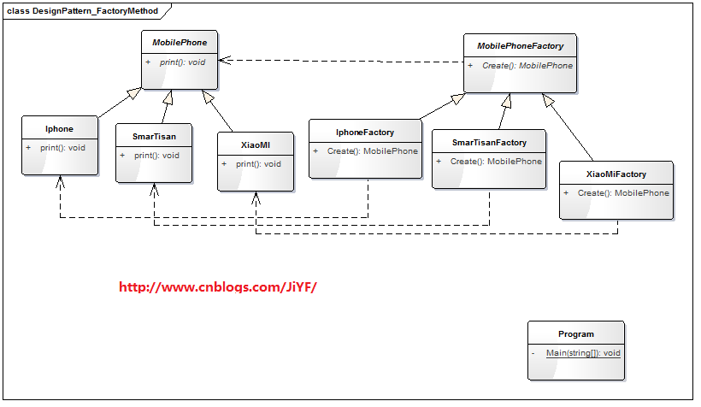

**工厂方法模式C#代码举例：**

**MobilePhone类手机类**

1 public abstract class MobilePhone

2 {

3 public abstract void print();

4 }

**Iphone 类 苹果手机类**

[复制代码](javascript:void(0);)

1 public class Iphone : MobilePhone

2 {

3 public override void print()

4 {

5 Console.WriteLine("我是苹果手机！");

6 }

7 }

[复制代码](javascript:void(0);)

**XiaoMI 类 小米手机类**

[复制代码](javascript:void(0);)

1 public class XiaoMI:MobilePhone

2 {

3 public override void print()

4 {

5 Console.WriteLine("我是小米手机");

6 }

7 }

[复制代码](javascript:void(0);)

**SmarTisan类 锤子手机类**

[复制代码](javascript:void(0);)

1 public class SmarTisan : MobilePhone

2 {

3 public override void print()

4 {

5 Console.WriteLine("我是锤子手机！");

6 }

7 }

[复制代码](javascript:void(0);)

**MobilePhoneFactory 类 手机工厂类**

1 public abstract class MobilePhoneFactory

2 {

3 public abstract MobilePhone Create();

4 }

**IphoneFactory 类 苹果手机工厂类**

[复制代码](javascript:void(0);)

1 public class IphoneFactory:MobilePhoneFactory

2 {

3 public override MobilePhone Create()

4 {

5 return new Iphone();

6 }

7 }

[复制代码](javascript:void(0);)

**XiaoMiFactory类 小米手机工厂类**

[复制代码](javascript:void(0);)

1 public class XiaoMiFactory:MobilePhoneFactory

2 {

3 public override MobilePhone Create()

4 {

5 return new XiaoMI();

6 }

7 }

[复制代码](javascript:void(0);)

**SmarTisanFactory类 锤子手机工厂类**

[复制代码](javascript:void(0);)

1 public class SmarTisanFactory:MobilePhoneFactory

2 {

3 public override MobilePhone Create()

4 {

5 return new SmarTisan();

6 }

7 }

[复制代码](javascript:void(0);)

**测试**

**（即使每次增加新的品牌，只需要增加新品牌的类，以及对应工厂即可使用，方便扩展）**

[复制代码](javascript:void(0);)

1 class Program

2 {

3 static void Main(string[] args)

4 {

5 //创建苹果手机工厂

6 MobilePhoneFactory mobilePhoneFactoryIphone = new IphoneFactory();

7 //苹果手机工厂创建手机

8 MobilePhone mobilePhoneIphone = mobilePhoneFactoryIphone.Create();

9 //由苹果工厂创建苹果手机

10 mobilePhoneIphone.print();

11

12

13 //小米工厂生产小米手机

14 MobilePhoneFactory mobilePhoneFactoryXiaoMi = new XiaoMiFactory();

15 MobilePhone mobilePhoneXiaoMi = mobilePhoneFactoryXiaoMi.Create();

16 mobilePhoneXiaoMi.print();

17

18

19 //锤子手机工厂生产锤子手机

20 MobilePhoneFactory mobilePhoneFactorySmarTisan = new SmarTisanFactory();

21 MobilePhone mobilePhoneSmarTisan = mobilePhoneFactorySmarTisan.Create();

22 mobilePhoneSmarTisan.print();

23

24 Console.Read();

25

26 }

27 }

[复制代码](javascript:void(0);)

**运行结果：**

